Ideation Phase
Define the Problem Statements

Date | 30 September 2026
Team ID | SWTID-2026-5086
Project Name | AI WeatherWise API
Maximum Marks | 2 Marks

Customer Problem Statement :
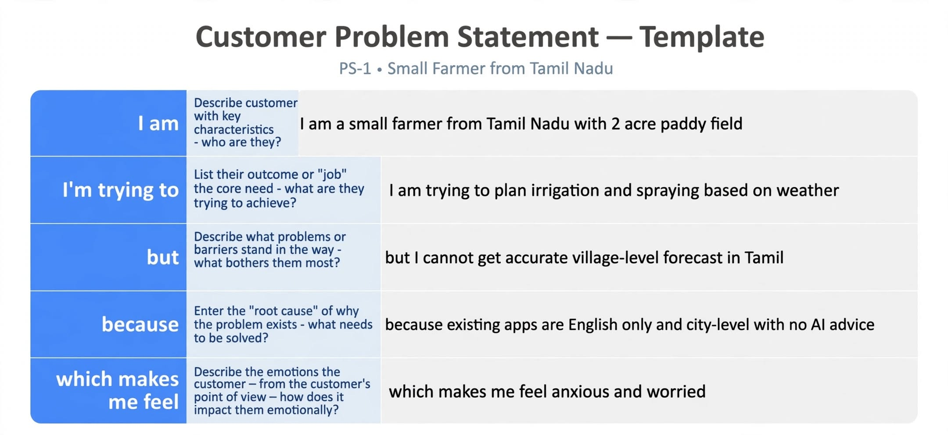
Example:
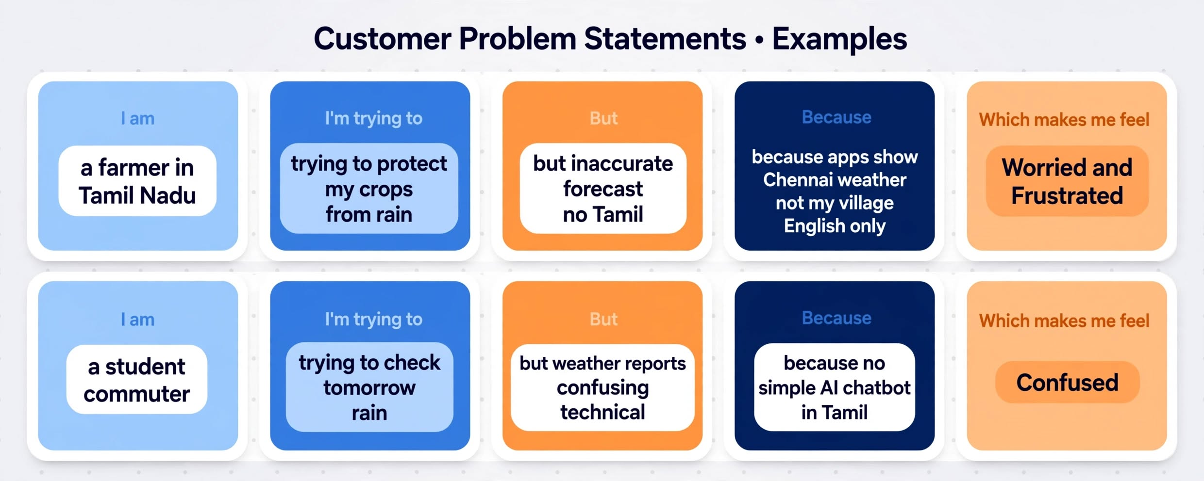

Problem Statement (PS) | I am (Customer) | I’m trying to | But | Because | Which makes me feel
PS-1 | I am a small farmer from Tamil Nadu with 2 acre paddy field | I am trying to plan irrigation and spraying based on weather | but I cannot get accurate village-level forecast in Tamil | because existing apps are English only and city-level with no AI advice | anxious and worried
PS-2 | I am a college student and daily bike commuter in Chennai | I am trying to check if it will rain tomorrow to plan my travel | Weather reports are confusing with technical terms and numbers | There is no simple AI chatbot to ask in Tamil or English like "Naalaiku mazhai peyyuma?" | Confused and unprepared

